1. *Calculate the resonant frequency of the circuit in Figure (****1****)* ***(5 marks)***

|  |  |
| --- | --- |
| Answer of Q1 |  |

1. *For the circuit shown in figure (****2****)* ***(10 marks)***
2. *If the frequency of the applied source is 12KHz , find the total impedance of the circuit in polar form.*
3. *Is the circuit is more inductive or more capacitive?*
4. *Find the total impedance of the circuit at resonance*

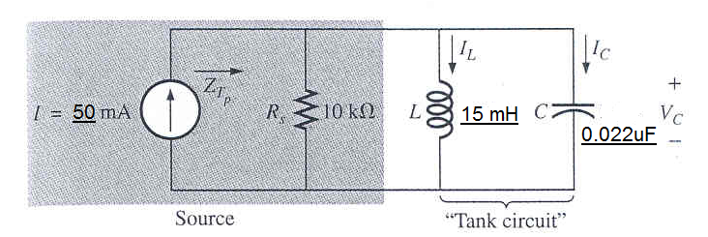

1. *It is required to broadcast a* ***shoubra******radio*** *station which detected through FM radio. Design a suitable practical parallel resonance circuit using coil has impedance of* ***10****+j****3000****Ω to verify the required broadcasting. The circuit has to be heard between (****89****MHz and* ***91*** *MHz) and very clear at 90MHz.* ***Don't use any approximations****.* ***(10 marks)***

|  |  |
| --- | --- |
| Answer of Q2 | Answer of Q2 |